Practical 1 Aim: Diabetes Prediction Using Pima Indians Dataset Code:
import pandas as pd import numpy as np
import matplotlib.pyplot as plt import seaborn as sns
from sklearn.model_selection import train_test_split from sklearn.ensemble import RandomForestClassifier
from sklearn.metrics import accuracy_score, confusion_matrix, classification_report

# --- Load dataset ---
url = "https://raw.githubusercontent.com/jbrownlee/Datasets/master/pima-indians-diabetes.data.csv" columns = [
'Pregnancies', 'Glucose', 'BloodPressure', 'SkinThickness', 'Insulin', 'BMI', 'DiabetesPedigreeFunction', 'Age', 'Outcome'
]
data = pd.read_csv(url, header=None, names=columns)

# --- Explore dataset ---
print("First 5 rows:\n", data.head()) print("\nInfo:\n")
print(data.info())
print("\nSummary Statistics:\n", data.describe())

# --- Clean data: replace zeros with median ---
cols_to_fix = ['Glucose', 'BloodPressure', 'SkinThickness', 'Insulin', 'BMI'] for col in cols_to_fix:
data[col] = data[col].replace(0, np.nan) data[col] = data[col].fillna(data[col].median())

# --- Correlation heatmap ---plt.figure(figsize=(10, 8))
sns.heatmap(data.corr(numeric_only=True), annot=True, cmap='coolwarm') plt.title("Correlation Matrix")

plt.tight_layout() plt.show()

# --- Outcome distribution ---plt.figure(figsize=(6, 4)) sns.countplot(x='Outcome', data=data) plt.title("Outcome Distribution") plt.tight_layout()
plt.show()

# --- Prepare training data ---
X = data.drop('Outcome', axis=1) y = data['Outcome']
X_train, X_test, y_train, y_test = train_test_split( X, y, test_size=0.2, random_state=42
)

# --- Train model ---
model = RandomForestClassifier(random_state=42) model.fit(X_train, y_train)
y_pred = model.predict(X_test)

# --- Evaluate model ---
accuracy = accuracy_score(y_test, y_pred) print(f"\nModel Accuracy: {accuracy * 100:.2f}%")
print("\nConfusion Matrix:\n", confusion_matrix(y_test, y_pred)) print("\nClassification Report:\n", classification_report(y_test, y_pred))

# --- Feature importance plot ---importances = model.feature_importances_
feat_importances = pd.Series(importances, index=X.columns) plt.figure(figsize=(10, 6)) feat_importances.sort_values().plot(kind='barh') plt.title("Feature Importance from Random Forest") plt.tight_layout()
plt.show()

# --- Predict for new sample patient ---new_patient_data = pd.DataFrame([{
'Pregnancies': 2,
'Glucose': 120,
'BloodPressure': 70,
'SkinThickness': 30,
'Insulin': 80,
'BMI': 25.6,
'DiabetesPedigreeFunction': 0.6,
'Age': 32
}])

prediction = model.predict(new_patient_data)
print("\nPrediction for new patient:", "Likely diabetic." if prediction[0] == 1 else "Unlikely diabetic.")

Output:
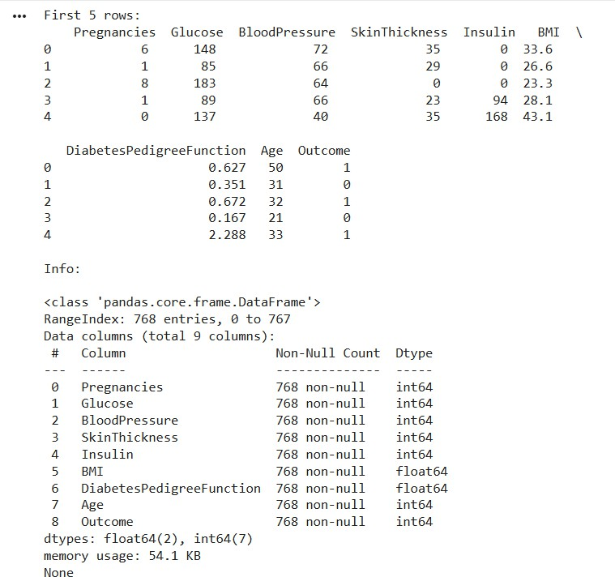

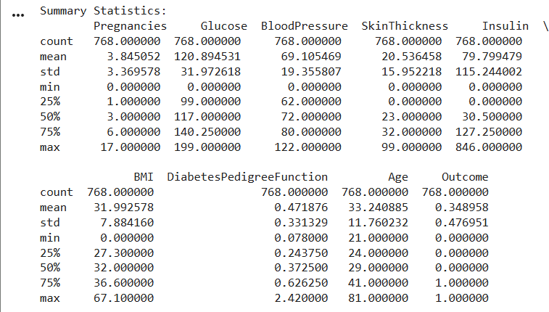

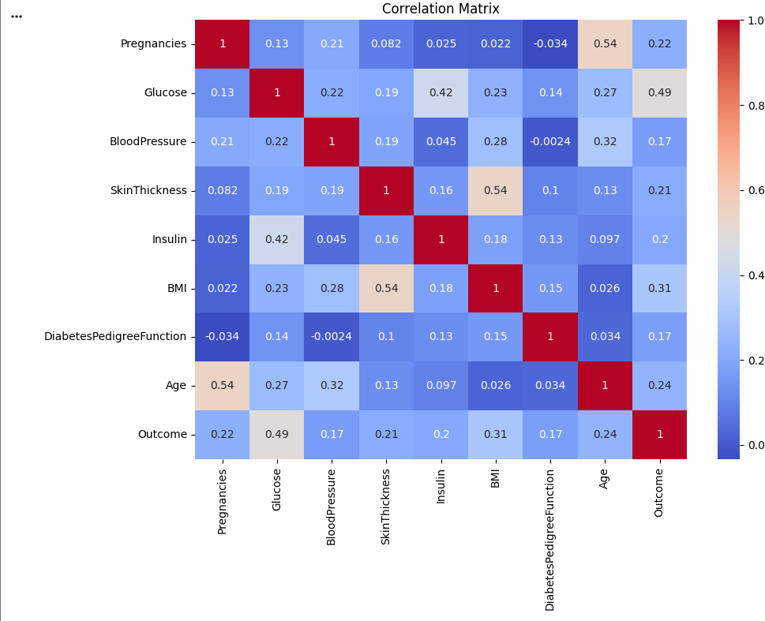

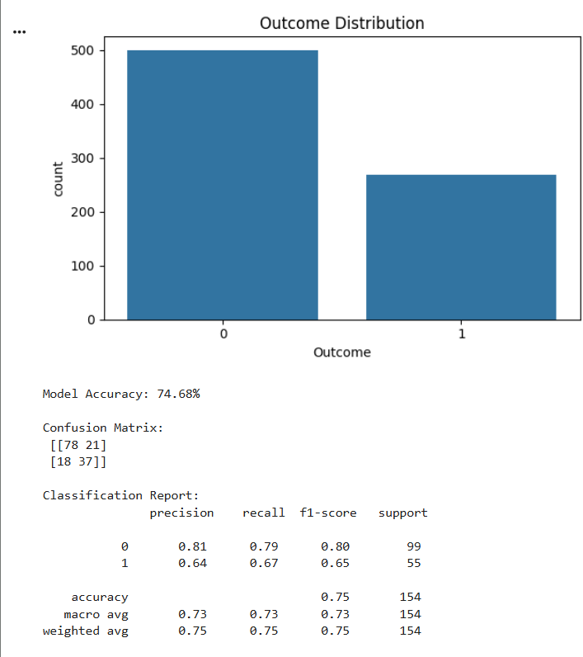
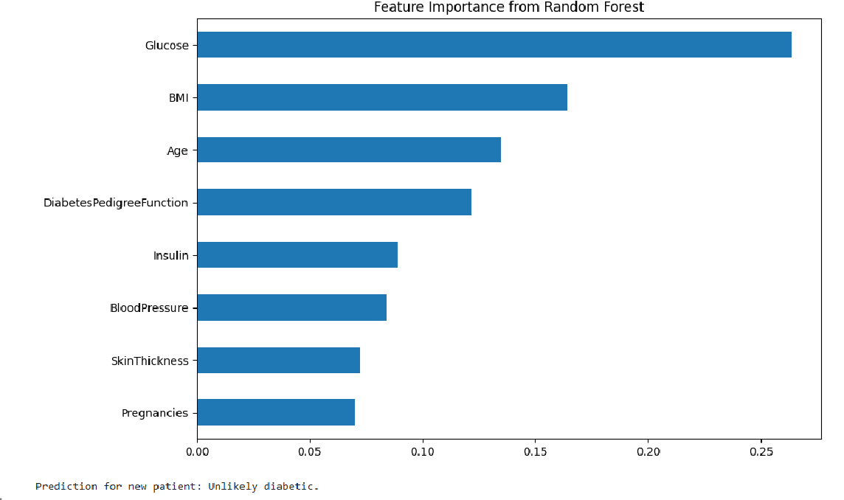

Practical 2
Aim: Student Academic Performance Prediction (Pass/Fail Classification) Code:
import pandas as pd
from sklearn.model_selection import train_test_split from sklearn.preprocessing import MinMaxScaler from sklearn.ensemble import RandomForestClassifier
from sklearn.metrics import accuracy_score, classification_report

# Load data
df = pd.read_csv('StudentsPerformance.csv')

# Drop 'StudentID' if it exists
df = df.drop(columns=['StudentID'], errors='ignore')

# Create 'Pass_Fail' based on average score passing_marks = 60
df['Pass_Fail'] = (df[['math score', 'reading score', 'writing score']].mean(axis=1) >= passing_marks).astype(int)

# Encode categorical columns
df = pd.get_dummies(df, drop_first=True)

# Features and target
X = df.drop('Pass_Fail', axis=1) y = df['Pass_Fail']

# Scale features
scaler = MinMaxScaler() X_scaled = scaler.fit_transform(X)

# Train/test split
X_train, X_test, y_train, y_test = train_test_split( X_scaled, y, test_size=0.2, random_state=42
)

# Train model
model = RandomForestClassifier(random_state=42) model.fit(X_train, y_train)

# Evaluation
y_pred = model.predict(X_test)
print("Accuracy:", accuracy_score(y_test, y_pred)) print(classification_report(y_test, y_pred))

Output:

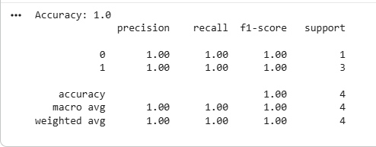

Practical 3
Aim: Customer Churn Prediction for Telecom Industry Code:
import pandas as pd
from sklearn.model_selection import train_test_split from sklearn.preprocessing import StandardScaler from sklearn.ensemble import RandomForestClassifier
from sklearn.metrics import accuracy_score, classification_report, confusion_matrix

# Load
df = pd.read_csv('P3WA_Fn-UseC_-Telco-Customer-Churn.csv')

# Clean
df['TotalCharges'] = pd.to_numeric(df['TotalCharges'], errors='coerce')
# Fix: Avoid chained assignment warning by assigning back the filled column df['TotalCharges'] = df['TotalCharges'].fillna(df['TotalCharges'].median()) df.drop('customerID', axis=1, inplace=True)

# Encode
df['Churn'] = df['Churn'].map({'Yes':1, 'No':0})
df.replace({'No phone service':'No', 'No internet service':'No'}, inplace=True) df = pd.get_dummies(df, drop_first=True)

# Split
X = df.drop('Churn', axis=1) y = df['Churn']
X_train, X_test, y_train, y_test = train_test_split( X, y, test_size=0.2, random_state=42, stratify=y
)

# Scale
num_cols = ['tenure', 'MonthlyCharges', 'TotalCharges'] scaler = StandardScaler()
X_train[num_cols] = scaler.fit_transform(X_train[num_cols]) X_test[num_cols] = scaler.transform(X_test[num_cols])

# Model
clf = RandomForestClassifier(random_state=42) clf.fit(X_train, y_train)
y_pred = clf.predict(X_test)

# Evaluate
print("Accuracy:", accuracy_score(y_test, y_pred)) print(classification_report(y_test, y_pred)) print(confusion_matrix(y_test, y_pred))

Output:

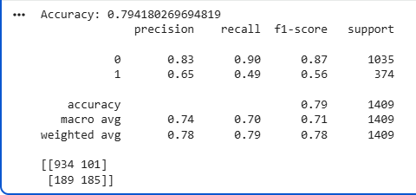

Practical 4 Aim: Email Spam Detection and Classification Code:
import pandas as pd
from sklearn.model_selection import train_test_split
from sklearn.feature_extraction.text import TfidfVectorizer from sklearn.naive_bayes import MultinomialNB
from sklearn.metrics import accuracy_score, classification_report

# Load (example: SMS Spam CSV)
df = pd.read_csv('spam.csv', encoding='latin-1')[['v1','v2']] df.columns = ['label', 'text']
df['label'] = df['label'].map({'spam':1, 'ham':0})

X_train, X_test, y_train, y_test = train_test_split( df['text'], df['label'], test_size=0.2, random_state=42
)

vectorizer = TfidfVectorizer(stop_words='english') X_train_tfidf = vectorizer.fit_transform(X_train) X_test_tfidf = vectorizer.transform(X_test)

clf = MultinomialNB() clf.fit(X_train_tfidf, y_train) y_pred = clf.predict(X_test_tfidf)

print("Accuracy:", accuracy_score(y_test, y_pred)) print(classification_report(y_test, y_pred))

Output :
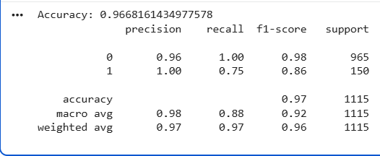

Practical 5 Aim: Time-Series Anamoly Detection Techniques Code:
import pandas as pd import numpy as np
from sklearn.ensemble import IsolationForest

df = pd.read_csv('your_timeseries.csv', parse_dates=['timestamp'], index_col='timestamp') series = df['value']

model = IsolationForest(contamination=0.01, random_state=42) df['anomaly'] = model.fit_predict(series.values.reshape(-1,1)) anomalies = df[df['anomaly'] == -1]
print("Anomalies found:", anomalies)

Output:

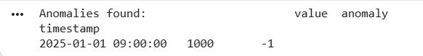

Practical 6 Aim: Human Activity Recognition Using Sensor Data Code:
import pandas as pd import numpy as np
from sklearn.model_selection import train_test_split from sklearn.ensemble import RandomForestClassifier from sklearn.metrics import classification_report

# --- Example dataset creation ---# 100 samples, 6 sensor features np.random.seed(42)
X = pd.DataFrame({
'accel_x': np.random.randn(100), 'accel_y': np.random.randn(100), 'accel_z': np.random.randn(100), 'gyro_x': np.random.randn(100), 'gyro_y': np.random.randn(100), 'gyro_z': np.random.randn(100),
})

# Example activity labels
activities = ['Walking', 'Running', 'Sitting'] y = pd.DataFrame({
'Activity': np.random.choice(activities, size=100)
})

# Save to CSV (optional) X.to_csv('X.csv', index=False) y.to_csv('y.csv', index=False)
print("⬛ Files 'X.csv' and 'y.csv' created successfully.")

# --- Load CSVs (simulating real dataset) ---X = pd.read_csv('X.csv')
y = pd.read_csv('y.csv')['Activity']

# Train/test split
X_train, X_test, y_train, y_test = train_test_split( X, y, test_size=0.2, random_state=42, stratify=y
)

# Train Random Forest classifier
clf = RandomForestClassifier(random_state=42) clf.fit(X_train, y_train)

# Predict and evaluate y_pred = clf.predict(X_test)
print("\nClassification Report:\n") print(classification_report(y_test, y_pred))

Output:
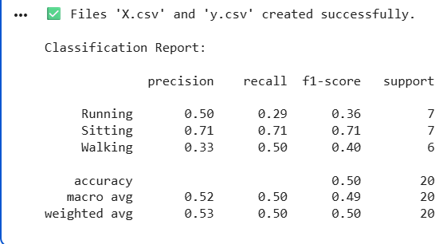

Practical 7
Aim: Wine Quality Prediction Using Machine Learning Code:
import pandas as pd
from sklearn.model_selection import train_test_split from sklearn.ensemble import RandomForestClassifier
from sklearn.metrics import accuracy_score, classification_report

df = pd.read_csv('winequality-red.csv', sep=';') df['good_quality'] = (df['quality'] >= 6).astype(int)

X = df.drop(['quality', 'good_quality'], axis=1) y = df['good_quality']

X_train, X_test, y_train, y_test = train_test_split( X, y, test_size=0.2, random_state=42
)

clf = RandomForestClassifier(random_state=42) clf.fit(X_train, y_train)
y_pred = clf.predict(X_test)

print("Accuracy:", accuracy_score(y_test, y_pred)) print(classification_report(y_test, y_pred))

Output:
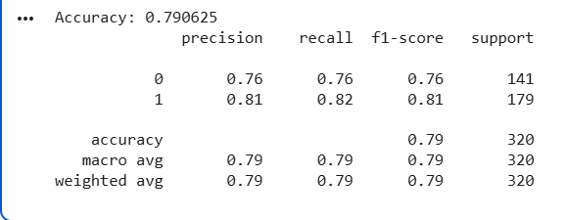

Practical 8 Aim: Loan Eligibility Prediction Model
Code:
import pandas as pd
from sklearn.model_selection import train_test_split from sklearn.ensemble import RandomForestClassifier
from sklearn.metrics import accuracy_score, classification_report

# Load and preprocess data
df = pd.read_csv('loan_data.csv')
df['Loan_Status'] = df['Loan_Status'].map({'Y': 1, 'N': 0}) df.drop(['Loan_ID'], axis=1, inplace=True)
df = pd.get_dummies(df, drop_first=True)

X = df.drop('Loan_Status', axis=1) y = df['Loan_Status']

# Stratified split with larger test size
X_train, X_test, y_train, y_test = train_test_split( X, y, test_size=0.3, random_state=42, stratify=y
)

# Print class distributions
print("Train class distribution:\n", y_train.value_counts()) print("Test class distribution:\n", y_test.value_counts())

# Train model
clf = RandomForestClassifier(random_state=42) clf.fit(X_train, y_train)

# Predict on test set
y_pred = clf.predict(X_test)

# Print actual vs predicted labels print("Actual labels:", y_test.values)

print("Predicted labels:", y_pred)

# Print accuracy and classification report (with zero_division=0 to avoid warnings) print("Accuracy:", accuracy_score(y_test, y_pred)) print(classification_report(y_test, y_pred, zero_division=0))

Output:
